**LAB 8: Sequential Circuits: Latch And SR Flip Flop**

**Question 1: Design an SR flip-flop using Logisim.**

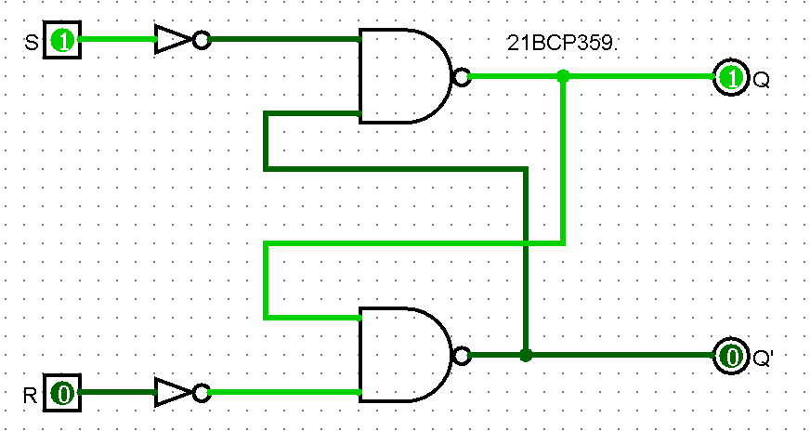

**Question 2: Write a module for NOR gate and develop a structural Verilog code for the S-R latch using the NOR gate module.** **Validate the code via a suitable Testbench code.**

**Expression:** Qn+1 = E.D + E'.Qn

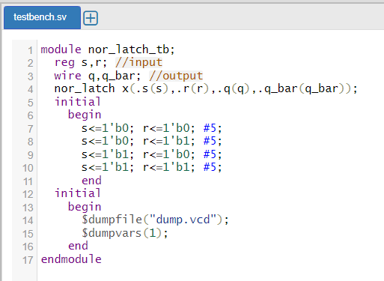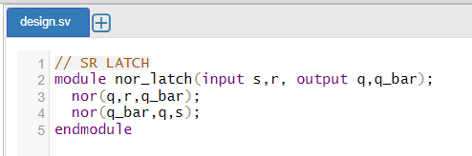



**Question 3: Write a Verilog module for NAND gate and utilize it to develop a structural Verilog module. Validate it using suitable Test bench.**

**Expression:** Qn+1 = S + QnR’

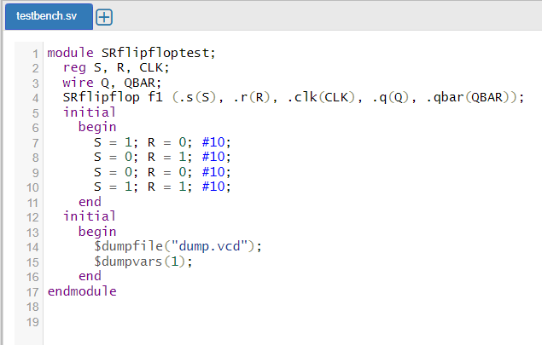  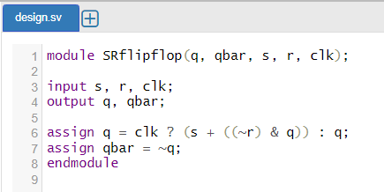



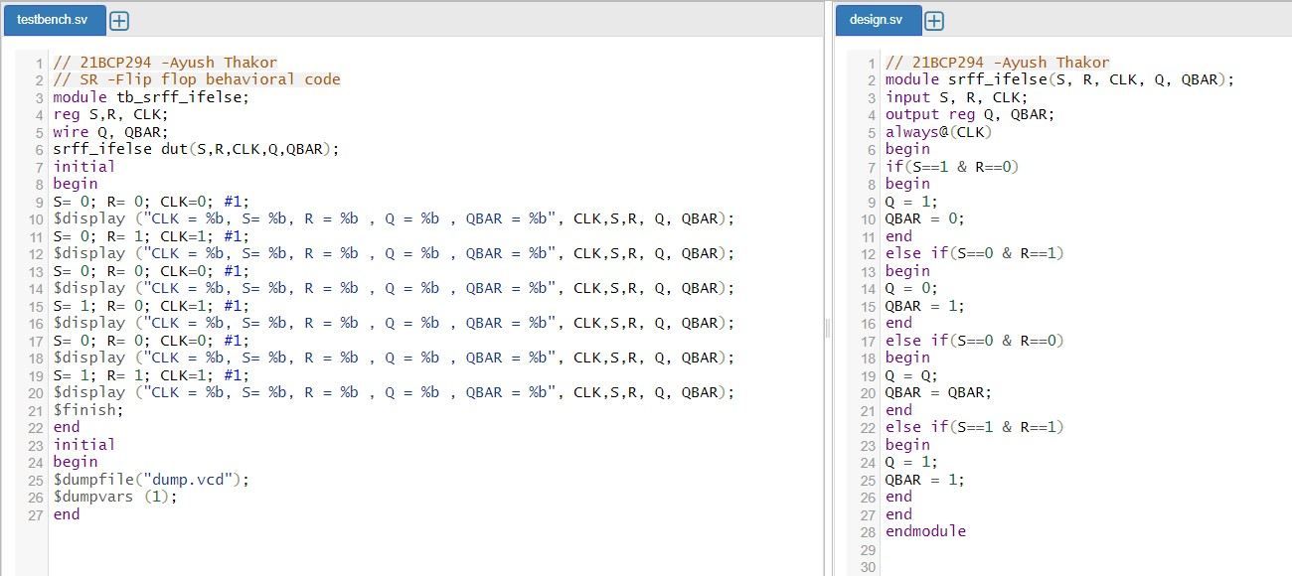**Q 4. Develop a similar behavioral code and test bench for S-R flip flop using if-else condition as per question 3.**



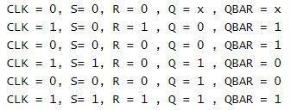

**Question 5: Develop a similar behavioural code and test bench for S-R flip flop using if-else condition as per question 3.**



